1.Write a python program about class variables using Robot Class.

class Robot:
"""Represents a robot, with a name."""
# A class variable, counting the number of robots
population = 0
def __init__(self, name):
"""Initializes the data."""
self.name = name
print("(Initializing {})".format(self.name))
# When this person is created, the robot
# adds to the population
Robot.population += 1
def die(self):
"""I am dying."""
print("{} is being destroyed!".format(self.name))
Robot.population -= 1
if Robot.population == 0:
print("{} was the last one.".format(self.name))
else:
print("There are still {:d} robots working.".format(
Robot.population))
def say_hi(self):
"""Greeting by the robot.
Yeah, they can do that."""
print("Greetings, my masters call me {}.".format(self.name))
@classmethod
def how_many(cls):
"""Prints the current population."""
print("We have {:d} robots.".format(cls.population))
droid1 = Robot("R2-D2")
droid1.say_hi()
Robot.how_many()
droid2 = Robot("C-3PO")
droid2.say_hi()
Robot.how_many()
print("\nRobots can do some work here.\n")
print("Robots have finished their work. So let's destroy them.")
droid1.die()
droid2.die()
Robot.how_many()
Output:
$ python oop_objvar.py
(Initializing R2-D2)
Greetings, my masters call me R2-D2.
We have 1 robots.
(Initializing C-3PO)
Greetings, my masters call me C-3PO.
We have 2 robots.
Robots can do some work here.
Robots have finished their work. So let's destroy them.
R2-D2 is being destroyed!
There are still 1 robots working.
C-3PO is being destroyed!
C-3PO was the last one.
We have 0 robots.

2.Implement instance variable concept for ATM Machine Class.
import random
import sys
class ATM():
def __init__(self, name, account_number, balance = 0):
self.name = name
self.account_number = account_number
self.balance = balance
def account_detail(self):
print("\n----------ACCOUNT DETAIL----------")
print(f"Account Holder: {self.name.upper()}")
print(f"Account Number: {self.account_number}")
print(f"Available balance: Nu.{self.balance}\n")

def deposit(self, amount):
self.amount = amount
self.balance = self.balance + self.amount
print("Current account balance: Nu.", self.balance)
print()

def withdraw(self, amount):
self.amount = amount
if self.amount > self.balance:
print("Insufficient fund!")
print(f"Your balance is Nu.{self.balance} only.")
print("Try with lesser amount than balance.")
print()
else:
self.balance = self.balance - self.amount
print(f"Nu.{amount} withdrawal successful!")
print("Current account balance: Nu.", self.balance)
print()

def check_balance(self):
print("Available balance: Nu.", self.balance)
print()

def transaction(self):
print("""
TRANSACTION
*********************
Menu:
1. Account Detail
2. Check Balance
3. Deposit
4. Withdraw
5. Exit
*********************
""")

while True:
try:
option = int(input("Enter 1, 2, 3, 4 or 5:"))
except:
print("Error: Enter 1, 2, 3, 4, or 5 only!\n")
continue
else:
if option == 1:
atm.account_detail()
elif option == 2:
atm.check_balance()
elif option == 3:
amount = int(input("How much you want to deposit(Nu.):"))
atm.deposit(amount)
elif option == 4:
amount = int(input("How much you want to withdraw(Nu.):"))
atm.withdraw(amount)
elif option == 5:
print(f"""
printing receipt..............
******************************************
Transaction is now complete.
Transaction number: {random.randint(10000, 1000000)}
Account holder: {self.name.upper()}
Account number: {self.account_number}
Available balance: Nu.{self.balance}

Thanks for choosing us as your bank
******************************************
""")
sys.exit()

print("*******WELCOME TO BANK OF BHUTAN*******")
print("___________________________________________________________\n")
print("----------ACCOUNT CREATION----------")
name = input("Enter your name: ")
account_number = input("Enter your account number: ")
print("Congratulations! Account created successfully......\n")

atm = ATM(name, account_number)

while True:
trans = input("Do you want to do any transaction?(y/n):")
if trans == "y":
atm.transaction()
elif trans == "n":
print("""
-------------------------------------
| Thanks for choosing us as your bank |
| Visit us again! |
-------------------------------------
""")
break
else:
print("Wrong command! Enter 'y' for yes and 'n' for NO.\n")

Output:
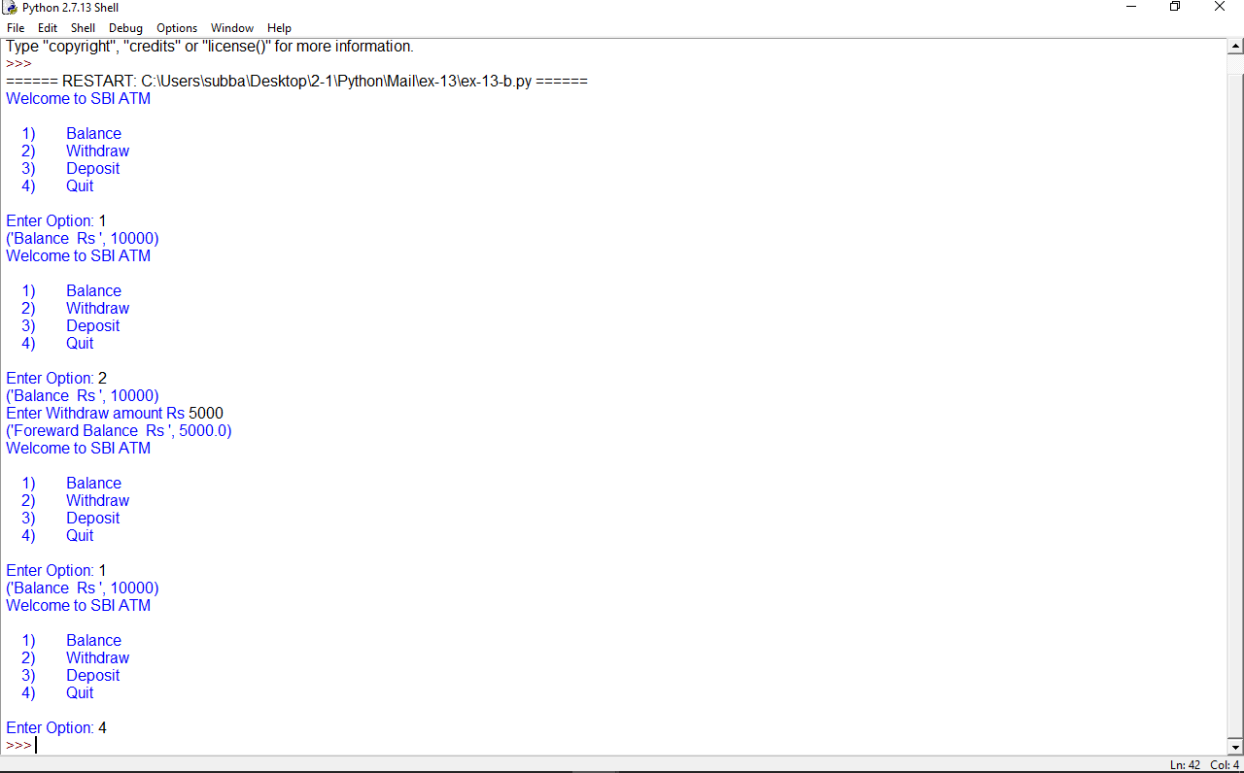

3.Write a program to implement Inheritance
class Bird:
def __init__(self):
print("Bird is ready")
def whoisThis(self):
print("Bird")
def swim(self):
print("Swim faster")
# child class
class Penguin(Bird):
def __init__(self):
# call super() function
super().__init__()
print("Penguin is ready")
def whoisThis(self):
print("Penguin")
def run(self):
print("Run faster")
peggy = Penguin()
peggy.whoisThis()
peggy.swim()
peggy.run()
Output
Bird is ready
Penguin is ready
Penguin
Swim faster
Run faster
4. Write a program to implement Polymorphism
class Parrot:
def fly(self):
print("Parrot can fly")
def swim(self):
print("Parrot can't swim")
class Penguin:
def fly(self):
print("Penguin can't fly")
def swim(self):
print("Penguin can swim")
# common interface
def flying_test(bird):
bird.fly()
#instantiate objects
blu = Parrot()
peggy = Penguin()
# passing the object
flying_test(blu)
flying_test(peggy)
Output
Parrot can fly
Penguin can't fly
5. Write a program to implement Data encapsulation
class Computer:
def __init__(self):
self.__maxprice = 900
def sell(self):
print("Selling Price: {}".format(self.__maxprice))
def setMaxPrice(self, price):
self.__maxprice = price
c = Computer()
c.sell()
# change the price
c.__maxprice = 1000
c.sell()
# using setter function
c.setMaxPrice(1000)
c.sell()
Output
Selling Price: 900
Selling Price: 900
Selling Price: 1000
6.Write a program to implement String Manipulation operations using python library Numpy.

NumPy String Functions
NumPy contains the following functions for the operations on the arrays of dtype string.
Sr.No. | Function & Description
1 | add()  Returns element-wise string concatenation for two arrays of str or Unicode
2 | multiply()  Returns the string with multiple concatenation, element-wise
3 | center()  Returns a copy of the given string with elements centered in a string of specified length
4 | capitalize()  Returns a copy of the string with only the first character capitalized
5 | title()  Returns the element-wise title cased version of the string or unicode
6 | lower()  Returns an array with the elements converted to lowercase
7 | upper()  Returns an array with the elements converted to uppercase
8 | split()  Returns a list of the words in the string, using separatordelimiter
9 | splitlines()  Returns a list of the lines in the element, breaking at the line boundaries
10 | strip()  Returns a copy with the leading and trailing characters removed
11 | join()  Returns a string which is the concatenation of the strings in the sequence
12 | replace()  Returns a copy of the string with all occurrences of substring replaced by the new string
13 | decode()  Calls str.decode element-wise
14 | encode()  Calls str.encode element-wise
1) numpy.char.add() method
import numpy as np
print("Concatenating two string arrays:")
print(np.char.add(['welcome','Hi'], [' to Javatpoint', ' read python'] ))
Output:
Concatenating two string arrays:
['welcome to Javatpoint' 'Hi read python']
2) numpy.char.multiply() method
import numpy as np
print("Printing a string multiple times:")
print(np.char.multiply("hello ",3))

Output:
Printing a string multiple times:
hello hello hello
3) numpy.char.center() method
import numpy as np
print("Padding the string through left and right with the fill char *");
#np.char.center(string, width, fillchar)
print(np.char.center("Javatpoint", 20, '*'))
Output:
Padding the string through left and right with the fill char *
*****Javatpoint*****
4) numpy.char.capitalize() method
import numpy as np
print("Capitalizing the string using capitalize()...")
print(np.char.capitalize("welcome to javatpoint"))
Output:
Capitalizing the string using capitalize()...
Welcome to javatpoint

5) numpy.char.title() method
import numpy as np
print("Converting string into title cased version...")
print(np.char.title("welcome to javatpoint"))
Output:
Converting string into title cased version...
Welcome To Javatpoint
6) numpy.char.lower() method
import numpy as np
print("Converting all the characters of the string into lowercase...")
print(np.char.lower("WELCOME TO JAVATPOINT"))
Output:
Converting all the characters of the string into lowercase...
welcome to javatpoint
7) numpy.char.upper() method
import numpy as np
print("Converting all the characters of the string into uppercase...")
print(np.char.upper("Welcome To Javatpoint"))
Output:
Converting all the characters of the string into uppercase...
WELCOME TO JAVATPOINT
8) numpy.char.split() method
import numpy as np
print("Splitting the String word by word..")
print(np.char.split("Welcome To Javatpoint"),sep = " ")

Output:
Splitting the String word by word..
['Welcome', 'To', 'Javatpoint']
9) numpy.char.splitlines() method
import numpy as np
print("Splitting the String line by line..")
print(np.char.splitlines("Welcome\nTo\nJavatpoint"))
Output:
Splitting the String line by line..
['Welcome', 'To', 'Javatpoint']

10) numpy.char.strip() method
import numpy as np
str = " welcome to javatpoint "
print("Original String:",str)
print("Removing the leading and trailing whitespaces from the string")
print(np.char.strip(str))
Output:
Original String: welcome to javatpoint
Removing the leading and trailing whitespaces from the string
welcome to javatpoint
11) numpy.char.join() method
import numpy as np
print(np.char.join(':','HM'))
Output:
H:M
12) numpy.char.replace() method
import numpy as np
str = "Welcome to Javatpoint"
print("Original String:",str)
print("Modified String:",end=" ")
print(np.char.replace(str, "Welcome to","www."))
Output:
Original String: Welcome to Javatpoint
Modified String: www. Javatpoint
13) numpy.char.encode() and decode() method
import numpy as np
enstr = np.char.encode("welcome to javatpoint", 'cp500')
dstr =np.char.decode(enstr, 'cp500')
print(enstr)
print(dstr)
Output:
b'\xa6\x85\x93\x83\x96\x94\x85@\xa3\x96@\x91\x81\xa5\x81\xa3\x97\x96\x89\x95\xa3'
welcome to javatpoint
7.Write a program to create a series using python library pandas.
import pandas as pd
a = [1, 7, 2]
myvar = pd.Series(a)
print(myvar)
Output
